

**GRACE SCHWINDT PRESS FILE**Table of contents

1. ‘A History of Touch’ – wall text
2. Information about selected works
3. International Women’s Day on 9 March – performances by the Hyster-X collective in Grace Schwindt’s exhibition
4. Grace Schwindt as ‘thinker in residence’ at M Leuven: a documentary

Extra info

Grace Schwindt’s website: <https://graceschwindt.net/>

M Leuven’s website: <https://www.mleuven.be/programma/grace-schwindt>

**‘A History of Touch’ by Grace Schwindt at M Leuven**

Grace Schwindt’s multidisciplinary practice encompasses drawing, performance, film, sculpture and painting. She explores the fragility of the human body, trauma and the healing power of touch and nurturing. Drawing on personal and physical experiences, she examines how memories and history are constructed and the impact of the capitalist system on our bodies, minds and collective memory.

Grace Schwindt is no stranger to M Leuven. She performed ‘Clean Air’, an exploration into assigning significance to landscapes, during the 2013 edition of the city’s Playground Festival. In 2018, she revisited the event with a group of sculptures and a video installation in the gallery spaces dedicated to the collection. She collaborated with Eva Wittocx on these projects, who has also curated ‘A History of Touch’.

In 2023, Schwindt was a visiting researcher at M’s depot, where she delved into the collection and the inner workings of the museum. She was struck by the care taken by the curators to preserve even the most deteriorated historical sculptures. This experience resonated with her broader research on the portrayal of the human body in Western culture, which often emphasizes strength and functionality over other qualities. Traditionally, fragility and damage are perceived as flaws to be concealed or remedied. Schwindt, however, views scars and wounds as a source of power, revitalization, and transformation. In the latest drawings, paintings and sculptures, she draws inspiration from the fractures and lacuna in the collection’s sculptures, seeking to create a fresh narrative about corporality.

‘A History of Touch’ includes existing and new works, the latter of which Schwindt created in response to her time at M. You can watch a documentary about the artistic journey, from exploring the depot to making the work and assembling this exhibition, in the room adjacent to the hallway.

14.02.2025 - 16.11.2025

Grace Schwindt

‘A History of Touch’

Curator: Eva Wittocx

**Grace Schwindt ‘A History of Touch’**

Information on selected works

**‘A History of Touch’**

(2024), glazed ceramic

A new home for ‘Christ on the Cold Stone’

In 2023, Grace Schwindt was a guest researcher at M’s depot. She was captivated by the meticulous way that the collection, including pieces that were damaged or fragmented, was preserved. One work in particular captured her interest: a severely damaged sculpture of ‘Christ on the Cold Stone’, a typical medieval depiction of a seated, suffering Christ just before the crucifixion.

Only fragments remained of this sculpture: a head, a torso and two legs. Schwindt decided to give these fragments a new home. The incompleteness of the sculpture inspired her to create a layered work: a kind of landscape in nine parts, with recesses in which a fragment of the Christ sculpture literally and figuratively rests. The remaining parts are suggested by glazed contours that allude to the original sculpture.

On the side of the sculpture, Schwindt has carved abstracted motifs of plants. For this, she researched the vegetation around Golgotha, the hill on which, according to tradition, Christ was crucified. We see leaves of olive trees and other plants that represent both the physical world and Christian iconography.

With this sculpture, Schwindt asks another surprising question in the margin: what was Christ’s environment before his death? The word ‘cold’ in the title of ‘Christ on the Cold Stone’ led her to think about physicality, touch and environment. These various elements encourage the viewer to perceive history not just as an isolated, factual event, but as a broader, more vibrant narrative, in which people are entwined with nature and their surroundings.

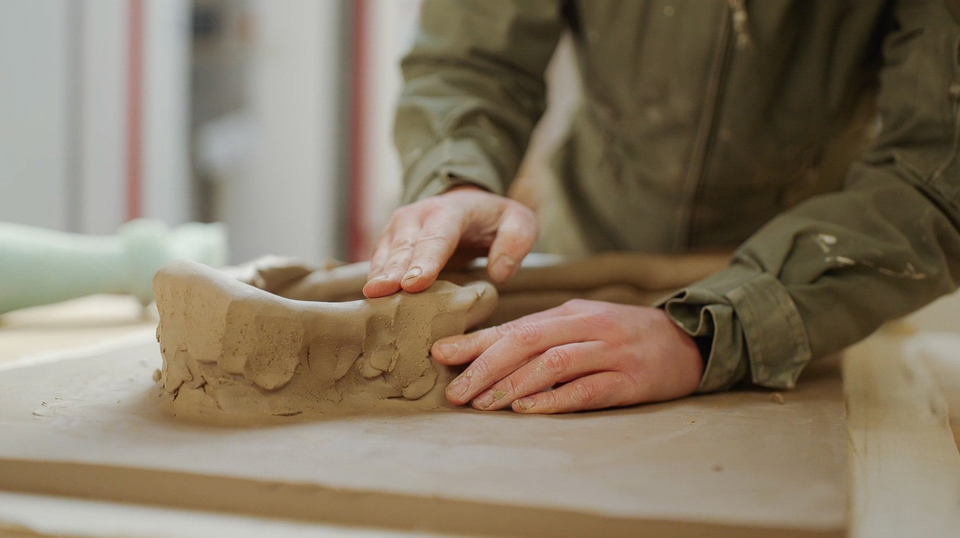

**‘When a Body Becomes a Landscape’**

Grace Schwindt working on ‘A History of Touch’ at the M’s depot © Salto Productions

(2024),Oil, ink and pencil on canvas

Paintings like monumental landscapes

Grace Schwindt has created five new large paintings, each featuring a human torso. These figures loosely refer to historical sculptures that she saw in the museum’s depot. In so doing, she noticed that these sculptures are usually stored horizontally, whereas they should stand or hang upright. This fact is reflected in her work, as she explores how the viewing direction of sculpture and painting can either clash with or complement meaning. The horizontal position is more restful and passive, while the vertical one seems more active.

The paintings evoke vivid landscapes in which the patina of ancient sculptures – traces of time, people and nature – come alive. In certain compositions, birds take centre stage, engaging in a dialogue with the human form and imbuing the work with a poetic tension. For Schwindt, birds represent transformation, protection and healing. They also carry many other meanings in art history.

Although Schwindt has been drawing and painting for some time, she only recently started working on canvas, and these are her first works in such a monumental format. These artworks demonstrate her innovative ability to transform sculptural references into the medium of painting.

When a Body Becomes a Landscape’, Grace Schwindt, 2024 © the artist, courtesy Galerie Peter Kilchmann, Zurich/Paris

**‘Leg Resting’**

(2024), Watercolour, pencil and ink on paper

Fragile encounters between form and colour

M’s depot also served as a source of inspiration for Schwindt’s watercolours. She photographed and sketched the hidden details of the sculptures, such as cracks and scars, as well as the backs of the works. Based on these observations, she created a series of drawings that straddle the line between figuration and abstraction. She zoomed in on fragments and also incorporated her own free forms.

Sometimes the compositions follow the contours of a damaged area. Other works introduce new elements, such as bird shapes, silhouettes of figures and abstract patterns.

Schwindt used watercolours, preserving the white of the paper as an essential element of the compositions. Fine lines alternate with deep ink stains and bright colours, striking a balance between fragility and power.

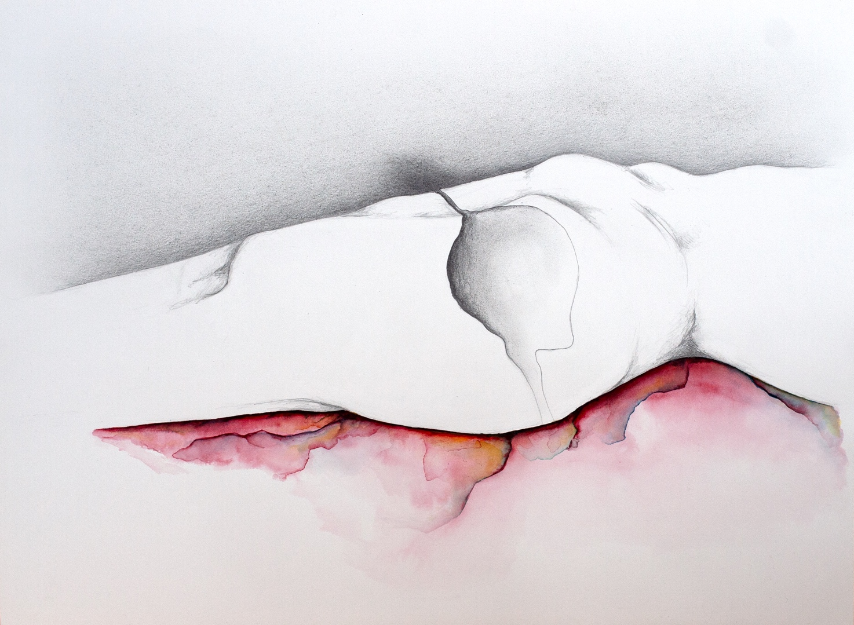

‘Leg Resting’, Grace Schwindt, 2024 © the artist,   
courtesy Galerie Peter Kilchmann Zurich/Paris

**‘Head and Figure’**

(2022), glazed ceramic

Strength and vulnerability

The exhibition also features Schwindt’s recent sculptures. The works depict figures at various stages of transformation: moments of rest, change and recovery. Moreover, the boundaries between humans and nature blur: leaves lean against heads, human forms merge with flowers, and birds assume serene poses.

A recurring theme in Schwindt’s work is how loss and pain can be sources of strength. Her sculptures bear visible signs of injury and fracture, often adorned with vibrant glazes, as if these areas of trauma have become a canvas for new narratives. Care and protection thus become essential steps on the path to healing.

Rigid materials like bronze contrast with pliable ones, such as delicate ceramics, thereby emphasizing the equilibrium between fragility and strength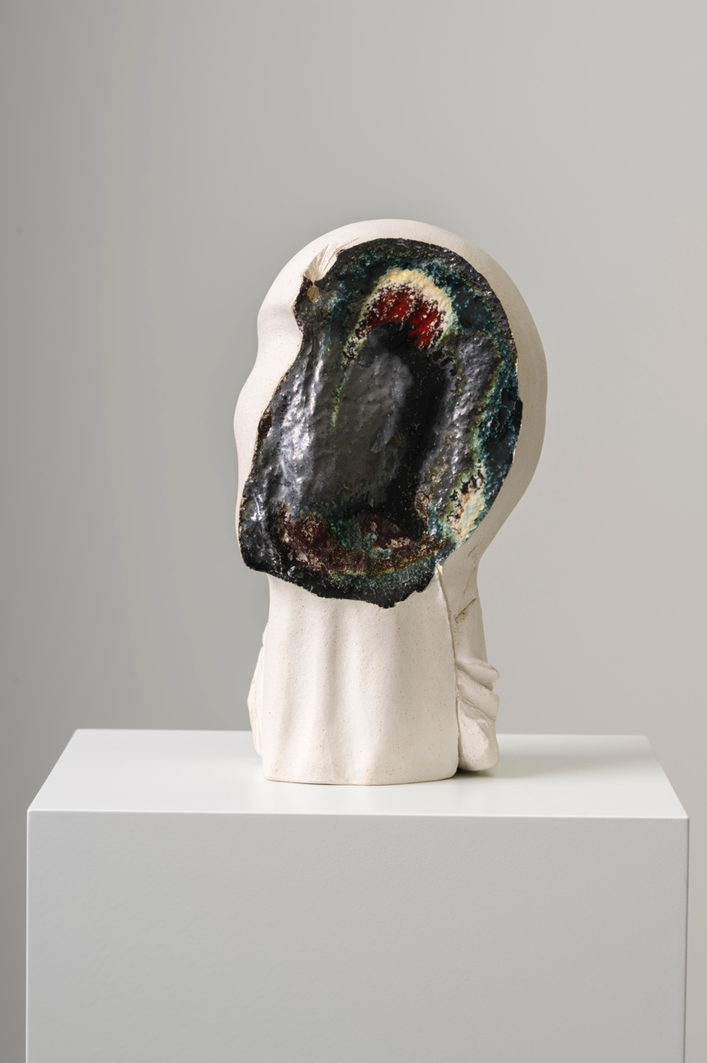.

‘Head and Figure’, Grace Schwindt, 2022 © the artist,   
courtesy Galerie Peter Kilchmann Zurich/Paris

**International Women’s Day on 9 March**

A poetic performance by the Hyster-X collective in Grace Schwindt’s exhibition

As part of M Leuven’s International Women’s Day celebrations, literary creators Mel(anie) Asselmans and Stefanie Huysmans-Noorts are diving into Grace Schwindt’s oeuvre. Guided by brushstrokes and sinking their teeth into the sculptures, they immerse themselves in the physicality of the work. They will transform their impressions into a poetic performance.

Mel (anie) Asselmans is a Brussels-based dreamy poet and spoken word artist. Her work reflects on the inherent complexity of human relationships.

In addition to being a writer and performer, Stefanie Huysmans-Noorts teaches writing, is artistic director of Dans! Dichter! Dans! and an editorial board member of *Deus Ex Machina*.

Both creators are members of Hyster-X, a writers’ collective for womxn and non-binary people living or working in Belgium. The collective publishes texts in Dutch, English and French and aims to empower and celebrate female and non-binary voices.

Between 6 and 9 March, M will celebrate International Women’s Day with an extensive programme of events, including a panel discussion, lectures, tours and children’s activities. Further details: www.mleuven/vrouwendag

Practical info

Hyster-X:

* Sunday 9 March, in Grace Schwindt’s exhibition at M Leuven:
  + Performance 1: 13:00 – 13:15
  + Performance 2: 15:15 – 15:30
* [Hyster-X | M Leuven](https://www.mleuven.be/programma/hyster-x)

**Interested in attending one of the performances? Send an email to:** [persm@mleuven.be](mailto:persm@mleuven.be?subject=Performance%20bijwonen%20Hyster-X)

**Grace Schwindt as ‘thinker in residence’ at M Leuven: a documentary**

M Leuven offered Grace Schwindt a residency in the depot in 2023, stemming from her interest in historical figures of Christ. During her stay, she studied a selection of sculptures. She also had many conversations with curators, restorers, the depot manager, and specialists in particular materials. Schwindt was impressed by the care that was taken with the objects, which were meticulously preserved despite often being in very poor condition. She took many photographs and made countless drawings. Eventually, she came up with an idea for a new ceramic sculpture, one that would engage in dialogue with several fragments of a damaged Christ figure.

In this video, we follow Grace’s journey, from her research in the depot to the realization of her new ceramic sculpture and preparation for her solo exhibition at the museum. This documentary provides a rare and intimate look into her artistic process and her perspective on the collection.

Running time: 15 minutes

In association with Salto Productions: anticipated launch is late March.

Watch the trailer [here](https://youtu.be/GpwF_n4z4AU)

The video can also be viewed during the exhibition.

Afbeelding met overdekt, meubels, persoon, tafel

Door AI gegenereerde inhoud is mogelijk onjuist.

Grace Schwindt at work in M’s depot © Salto Productions